NORTH LANCASHIRE ROAD CLUB

PRESENTS

The Circuit of the Dales

A NLTTA SpoCo counting Event

Promoted for and on behalf of Cycling Time Trials under their rules and regulations on
Sunday, 7th April 2024

Course L503/2

Timekeepers: Terry Parker (start) Tracey Moore (finish)
Event Secretary: Peter Briscoe 01254 888999 / 07787 987854 peter_briscoe@sky.com

Event Headquarters
Ingleton Community Centre
Ingleton, North Yorkshire
LA6 3HG
Please sign on and collect your number at the headquarters from 07:30am where a copy of the course risk assessment will be available.

Please follow these essential rules.
Complete a parental consent form if under the age of 18.
Do not warm up or cool down on the course.
Sign on before riding.
Attach your race number.
Wear an approved helmet.
Have a working front light.
Have a working rear light.
Start at your allocated time.
Obey the Highway Code.
Follow the course.
Don’t interact with other riders on the course.
Don’t have a preceding or following vehicle.
Call out your number at the finish.
Sign off after finishing.
Return your race number.

First competitor off at 08:31 am

Please do not forget to pay and display in the car park.

The following Local Regulations have been approved by the National Committee in accordance with regulation 38. any breaches may lead to disciplinary action

CTT Regulation 17: Signing-on Sheet and Signing-Out Sheet:
(a)The competitors in all events must make themselves aware of any special safety instructions for the event and sign the official Signing-on Sheet when collecting their number
(b) In open (Type A) events a competitor must return to the events HQ either during the event or within a reasonable time after the last rider has finished the event and must (i) return their number and (ii) sign the official Signing-out Sheet.

CTT Regulation 22: Use of motor vehicles:

A competitor shall not be preceded, accompanied, followed by or in any way receive assistance from a motorised vehicle or its occupants except in distances of 100 kms or more.

(Local Reg no 5)
In all events competitors, prior to starting, are not permitted to ride past the finish timekeeper during the duration of the event
(Local Reg no 6)
Riders making U-turns in the vicinity of the start and finish area will be disqualified from the event

(Local Reg no 15)
Riders must keep to the left-hand side of the road except when overtaking. Failure to comply with the above may lead to disqualification.

In addition to the above
Riders must not stand in the road at the start or finish (this constitutes an obstruction and is a breach of regulation 49)
Riders must give their number at the finish and elsewhere on the course when requested
Riders must not ride with their heads down. Regulation 50

Regulation 14 :-
All competitors must have illuminated front and rear lights on their cycle -
(i) No competitor shall be permitted to start either a Type A or Type B event unless such competitor has affixed to the rear of their machine a working rear red light, either flashing or constant, that is illuminated and in a position that is clearly visible to other road users.
(j) No competitor shall be permitted to start either a Type A or Type B event unless such competitor has affixed to the front of their machine a working front white light either flashing or constant, that is illuminated and in a position that is clearly visible to other road users.

Regulation 15. Protective Helmets
All competitors must wear a properly affixed helmet which must be of hard/soft shell construction. Helmets should conform to a recognised Standard such as SNELL B95, ANSI Z90.4, AUS/NZS 2063:96, DIN 33-954, CPSC or EN1078. It is the responsibility of the rider to:
(a) Select a helmet that offers protection against head injury and does not restrict rider’s vision or hearing.
(b) Ensure that the helmet is properly fitted, is undamaged and in good condition.

Please note riders without a working front light or rear light or a helmet will not be allowed to start

Guidance Note (specific to L503R)

Riders must ride safely and obey traffic signs at all times when riding a time trial. Be aware that this course contains a section of road (through Burton in Lonsdale) with a 20mph speed limit and extra care must be taken when negotiating this part of the course.

Attention all competitors
Please note that all competitors are now required personally to sign the signing out sheet when returning their number.

Failure to do so will result in the competitor being recorded as DNF.
:

COURSE DETAILS

Start on A687 approximately 50 yards after junction with A65 by the Country Harvester outlet north of Ingleton at west end of field gate on south side of road. Proceed west on A687 through Burton-in-Lonsdale to Greta Bridge and junction with A683 where straight on (Care) to junction with A65 main Kendal road.
Fork left down the hill then turn right (Care) on to A683 main Sedbergh road (8.73 miles /160ft). Proceed through Casterton and Middleton to join the A684 main Hawes road (18.52 miles/370 ft).
Fork right onto A684 and proceed to Sedbergh Main Street, where sharp right to mini roundabout (Care). Left at roundabout onto Back lane; take the right turn beyond the village along the A684 through Garsdale to the Moorcock Inn (29.40 miles/ 802ft).
After a further 4 miles, KEEP RIGHT over Yore Bridge through Appersett to the top end of Hawes village (34.56 miles/802ft). Turn sharp right (Care) up the hill on to B6255 Ingleton road and proceed via Newby Head (40.58 miles/ 1421ft) and Ribblehead (44.70 miles /980ft) to FINISH at signpost ‘bend’ and ‘12%’ gradient and adjacent to ‘SLOW’ sign on road at start of descent into Ingleton. (50m).
Note – take care immediately after the finish; slow down to safely take the corner and descent back to the HQ.

Some of the roads used by the event are rural and somewhat rough, as a result please take care all around the course, especially if wet.

In total there is about 3600 feet of climbing, and a bottom gear of around 57” is recommended.

WARNING
Please take every care at all points on the course and in particular at the following:

- Junction at Greta Bridge; give way as you join the main road.
- Take extreme care as you turn left onto the A65 at Kirby Lonsdale and then after 200 yards right onto the A683 Sedbergh road (traffic). Do not cut the corner.
- Sedbergh village (20m) road narrows just before the high street just before the turn sharp right
- At the two blind, right angled, bends around Garsdale churchyard. (25m)
- The fast descent though Chapel-le-dale. (46m

DIRECTIONS TO THE START

Leave car park from Northern Exit and turn left into main Street, continue to junction with A65. Turn right onto A65 and proceed in a northerly direction over the bridge to turn left onto A687 at Country Harvester, the start is approx. 50 yards from the junction.

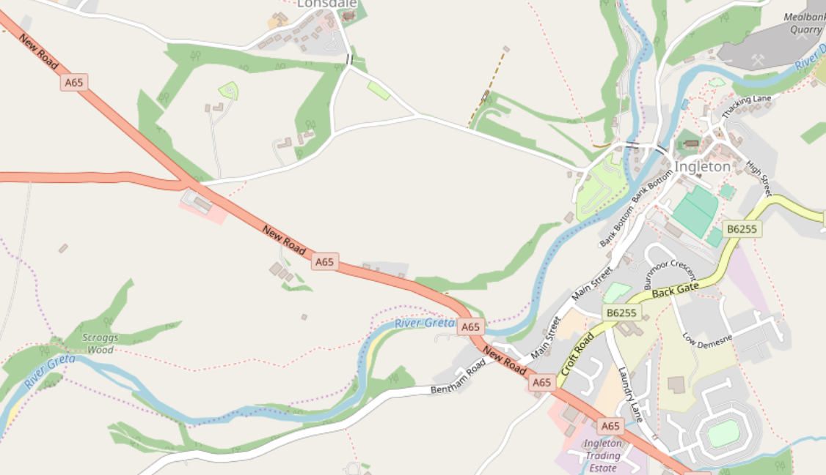
Ingleton Community Centre
Start is just after the left turn at the Country Harvester

Prizes (one prize per rider except team)

Overall
Both time trial and road bike categories are eligible for the overall awards.

Open Female

1st £50 £50
2nd £30 £30
3rd £20 £20
Junior / Youth £15 £15
V40 £15 £15
V50 £15 £15
V60 £15 £15
V70 £15

Road Bike

Open Female

1st £30 £30
2nd £15 £15

All rides, TT, road, open, female count to the fastest team of 3 prize of £30

Prize money will be paid by bank transfer, please send bank account details to the event secretary.

Good luck to all riders, have a safe and enjoyable ride

Previous Winners
1947 | G Thomas | Yorkshire RC | 2:19:07
1948 | No Promotion
1949 | LH Murgatroyd | Yorkshire Century RC | 2:33:37
1950 | S Haslam | Lancashire RC | 2:24:31
1951 | P Whitehead | Otley CC | 2:35:46
1952 | J Pilling | Cheshire RC | 2:24:11
1953 | MJ Wall | Preston Whs | 2:22:13
1954 | A Grisedale | Wigan Whs | 2:20:16
1955 | AS Britain | Phoenix CC | 2:24:53
1956 | AS Britain | Phoenix CC | 2:26:06
1957 | B Bradley | Southport RCC | 2:16:35
1958 | VA Denson | Yorkshire RC | 2:14:16
1959 | J Geddes | Army CC | 2:13:14
1960 | A Ramsbottom | N Lancs Clarion | 2:12:11
1961 | MJ Cowley | Derwent Valley Whs | 2:13:13
1962 | MJ Cowley | Derwent Valley Whs | 2:17:01
1963 | EG Valentine | Oldham Century | 2:35:15
1964 | R Smith | Bolton Clarion | 2:13:26
1965 | R Miller | Preston Whs | 2:18:11
1966 | EG Valentine | Oldham Century | 2:22:35
1967 | KW Stacey | Seamons CC | 2:16:25
1968 | EJ Watson | Clifton CC | 2:10:11
1969 | P Smith | Clifton CC | 2:10:38
1970 | H Armstrong | Tyne RC | 2:20:13
1971 | DC Lloyd | Kirby CC | 2:11:04
1972 | V Smith | Hull Thursday RC | 2:11:35
1973 | H Wilkinson | Warrington RC | 2:12:14
1974 | R Allsop | Cleveleys RC | 2:12:57
1975 | MJ Gadd | Cleveleys RC | 2:18:22
1976 | F Lyon | Kirby CC | 2:15:26
1977 | IL Greenalgh | West Pennine RC | 2:13:27
1978 | V Smith | CC Orpington Sabe | 2:15:05
1979 | R Swailes | Kent Valley RC | 2:24:16
1980 | DC Lloyd | Birkenhead NE | 2:09:22
1981 | DC Lloyd | Manchester Whs | 2:02:42
1982 | DC Lloyd | Manchester Whs | 2:01:13
1983 | DC Lloyd | Manchester Whs | 2:08:30
1984 | DC Lloyd | Manchester Whs | 2:06:23
1985 | DJ Smith | Horwich CC | 2:10:06
1986 | DJ Smith | Horwich CC | 2:13:20
1987 | Chris Boardman | Manchester Whs | 2:08:25
1988 | G Pickford | CC Bowland | 2:20:10
1989 | Chris Boardman | Manchester Whs | 2:10:29
1990 * | Peter Greenwood | Clayton Velo | 2:10:50
1991 | Martin Brass | Craven CC | 2:29:35
1992 | Martin Bowes | Cleveleys RC | 2:10:36
1993 | Gethin Butler | RT Italia | 2:05:32
1994 | Gethin Butler | RT Italia | 2:02:13
1995 | Gethin Butler | Norwood Paragon | 2:05:53
1996 | Gethin Butler | Norwood Paragon | 2:02:09
1997 | Gethin Butler | Norwood Paragon | 1:58:52
1998 | Gethin Butler | Norwood Paragon | 1:57:51
1999 * | P Smith | Border City Whs | 2:06:31
2000 * | Kevin Dawson | Pete Read Racing | 1:52:02
2001 | No Promotion (foot & mouth)
2002 | Dave Cook | Middridge CRT | 2:02:56
2003 | Gethin Butler | Preston Whs | 2:00:18
2004 | Gethin Butler | Yorkshire RC | 2:13:54
2005 | Gethin Butler | Preston Whs | 2:02:49
2006 | Gethin Butler | Preston Whs | 1:59:59
2007 * | Gethin Butler | Preston Whs | 1:58:39
2008 | Mark Holton | ProBikeKit.com | 2:03:25
2009 * | Mark Holton | Shorter Rochford RT | 1:57:25
2010 | Mark Holton | www.drag2zero.com | 1:56:52
2011 | Andrew Wilkinson | Port Sunlight Whs | 2:05:00
2012 * | Richard Handley | Rapha Condor Sharp | 1:55:38
2013 | Richard Handley | Rapha Condor JLT | 2:01:54
2014 | James Gullen | Velosure-Giordana RT | 2:02:37
2015 * | Mark Holton | www.drag2zero.com | 2:15:24
2016 | No Promotion (road works)
2017 | Phil Graves | NOPINZ | 2:03:45
2018 # | James Gullen | JLT Condor | 1:55:38
2019 | Brian Fogarty | Fogarty’s Insurance Tri Team | 2:01:23
2020 | No Promotion (Covid)
2021
2022 # | Richard Bideau | Pendle Forest CC | 2:01:11
2023 # | Patrick Casey | Anexo Group Race Team | 1:56:17

. * Denotes short course.
# Denotes course record
Nb New course L503/2 from 2021

